Using the Menu Class

The **Menu** class is in a package called **util**. It requires that you provide an **import** as seen in the example below. The **Menu** class can be used to create and display a menu and get and verify the user’s choice from it.

Required import

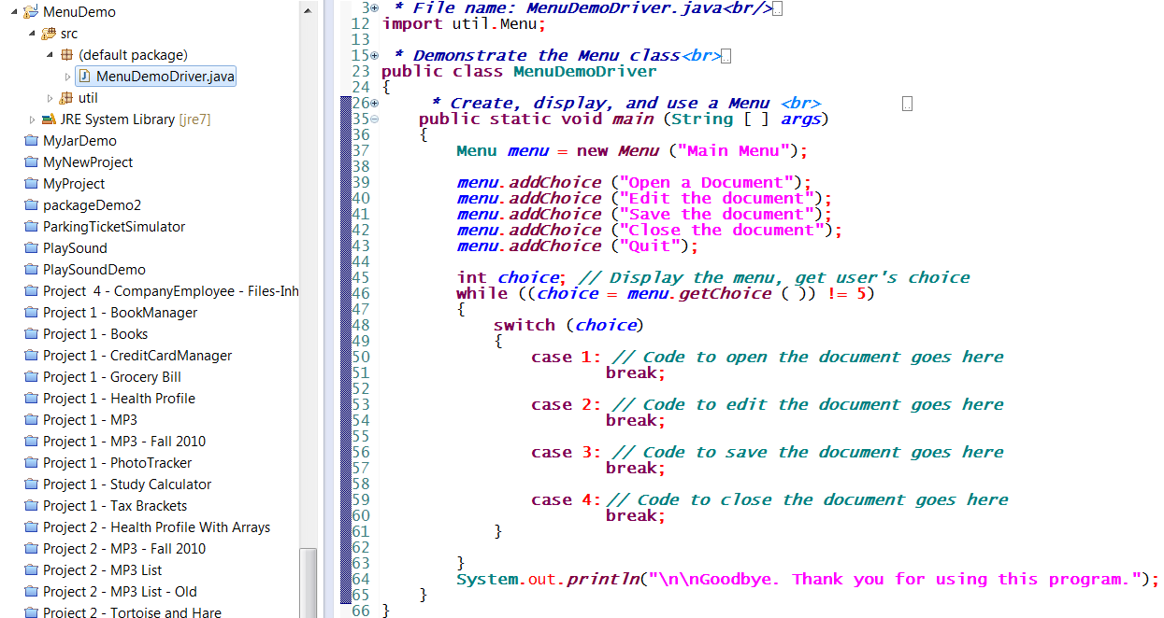

Project structure

Add up to 15 choices one at a time

Instantiate **Menu** object and give it a title

Display menu and get the user’s choice. Use **menu.getChoiceDialog ( )** instead to display menu as a **JOptionPane** dialog

Resulting menu display on the console window:

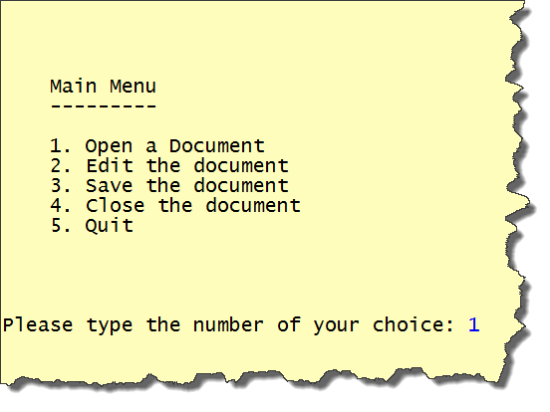

Menu class verifies the number typed here is valid before returning it to the driver. An error message is displayed if it is invalid.

Resulting menu display – notice the title is as specified on line 37 of the code above, and the choices are as defined on lines 39-43

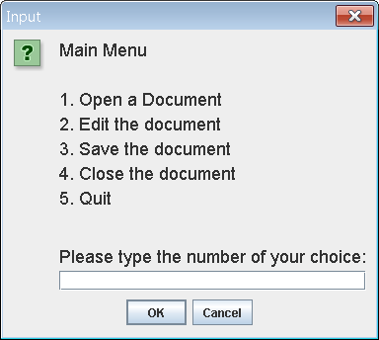

Menu displayed as a JOptionPane dialog instead using **getChoiceDialog( )**

# Setting up the Project

To set up your project properly as shown on the previous page, take the following steps.

1. Create a ***new project*** as you usually do in ***Eclipse***.
2. Expand the project so that you can see the ***src*** folder in the ***Package*** ***Explorer***
3. Right-click on the ***src*** folder and choose ***New*** and then ***Package*** as shown here

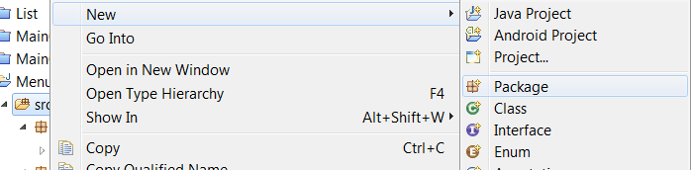

1. In the dialog that is displayed, name the new package ***util*** (no upper case characters). Close the dialog.
2. Right-click on the new ***util*** package in your project, and ***Import*** the ***Menu***.***java***, and ***Util***.***java*** files from wherever you saved them into the ***util*** package in your project.
3. Add the ***java*** files that you are creating for the project into the ***default*** package. The result should look similar to the project in the screenshot on the previous page.